Operating Systems
An operating system is a piece of software that manages all the resources of a computer system, both hardware and software, and provides an environment in which the user can execute his/her programs in a convenient and efficient manner by hiding underlying complexity of the hardware and acting as a resource manager.
- Resource Management.
- Acts as an interface between user and hardware.
- Isolation and Memory Protection of programs.
- Abstraction.
- Goals of OS-> Maximum CPU utilization, No process starvation, high priority execution.
- Types of OS->
- Single Process
- Batch Process
- Multi-programming OS (single CPU context switching saving states in PCB)
- Multi-tasking (single CPU Time-sharing)
- Multi-processor (context switching, time sharing, multiple CPUs)
- Distributed OS (network connected multiple components)
- RTOS (real-time error free computations).
- Program is a compile-ready executable file in Disk containing a certain set of instructions to complete a job on the computer.
- Process is a program under execution in RAM.
- Components of OS-
- User Space- Apps run here. No hardware access. GUI/CLI.
- Kernel- Access to underlying hardware. Helps in Process, Memory and File, I/O management.
  - Monolithic Kernel- has all managements in a shared space. Fast but unreliable (one crashes, system fail), bulky kernel.
  - Micro Kernel- File and I/O in User Space, Process and Memory in Kernel. Reliable, less bulky kernel but low performance as more interrupts.
  - Hybrid Kernel- File in User Space; I/O, Process and Memory in Kernel. Used in MAC, Windows.
User and Kernel mode communicate through IPC (Inter-Process Communication) via either shared memory or system calls.
System Calls
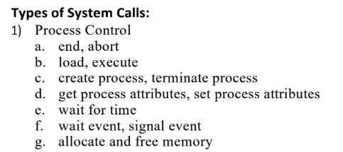
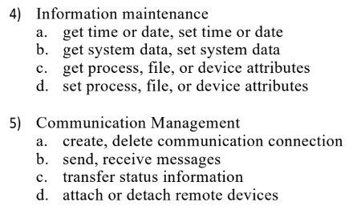
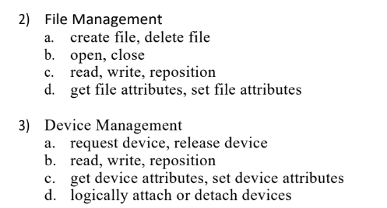

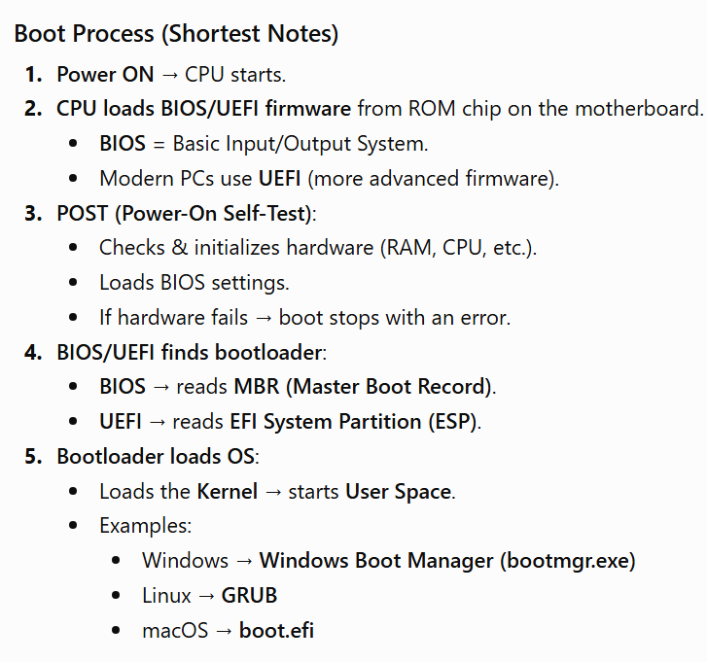
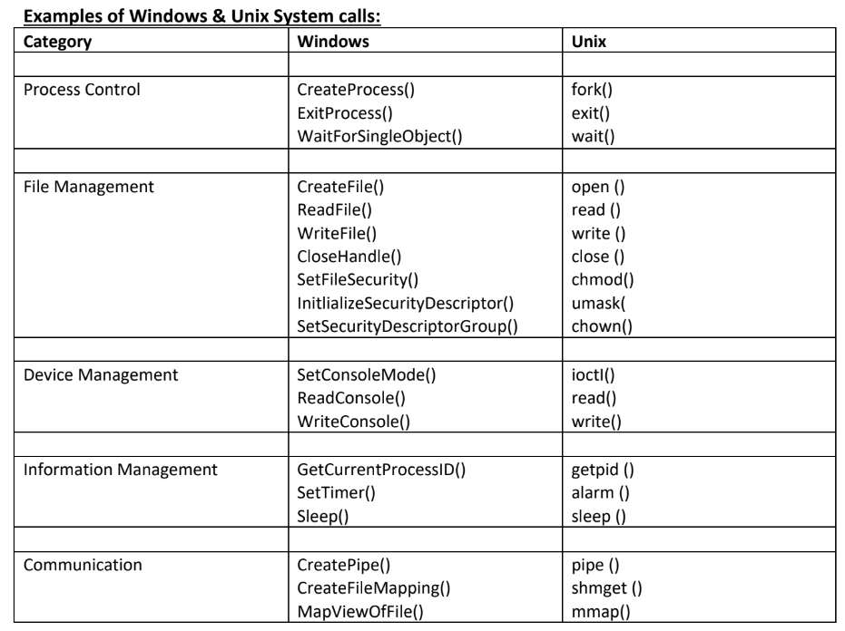
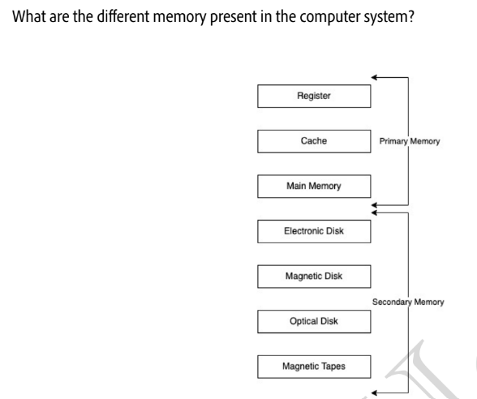
a. Primary memory is volatile and more expensive and has higher access speed.
b. Secondary is non-volatile and cheaper and has lower access speed but larger storage size.

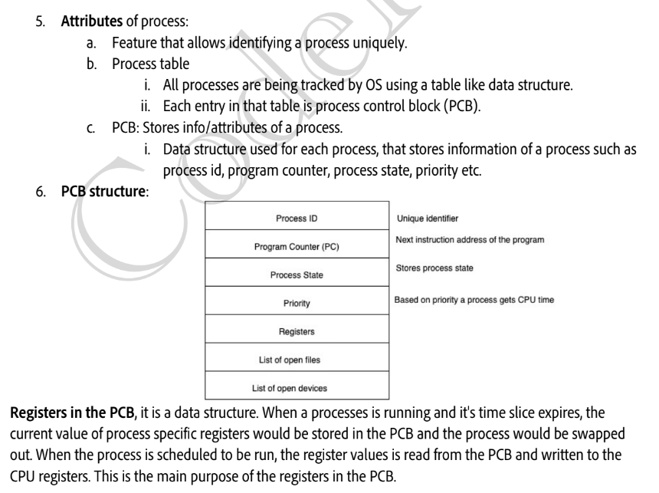
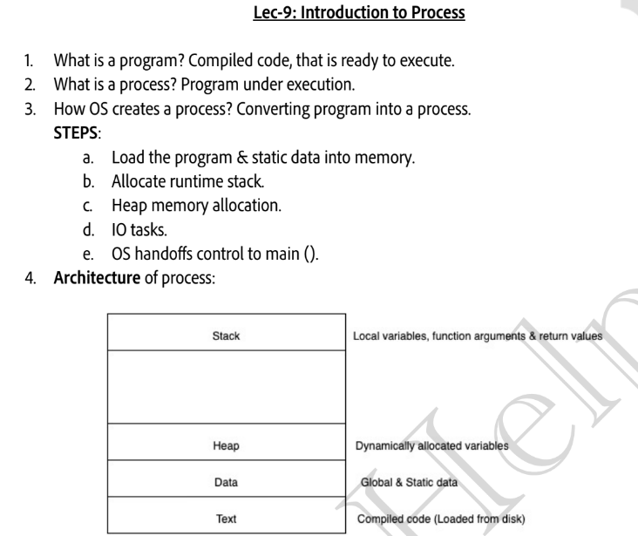
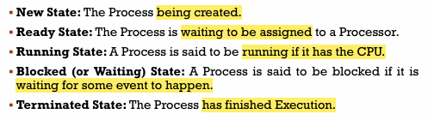
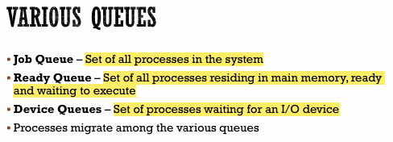
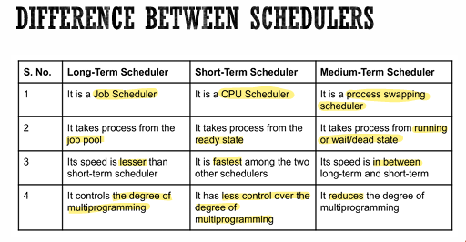
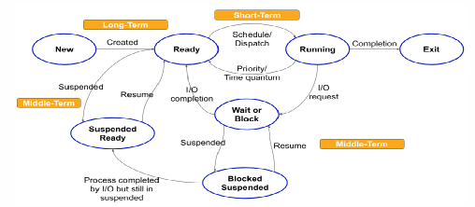
Process States and Queues

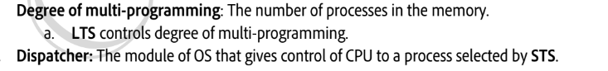
Dispatch Latency – Time it takes for the Dispatcher to Stop one process and Start another Running
Swapping
- Done by: Medium-Term Scheduler (MTS).
- Purpose: Reduce degree of multiprogramming / free memory.
- Process: Swap-Out (RAM → Disk) → Swap-In (Disk → RAM) → resumes execution.
- Need: When memory is overcommitted or to improve process mix.
Context Switching
- CPU switches from one process to another.
- Kernel saves current process context in PCB and loads new process context.
- Overhead: No useful work is done during the switch.
- Speed depends on memory speed and number of CPU registers.
Process Scheduling- When a process waits or time quantum expires, CPU is assigned to another process. Basis of Multiprogramming OS. CPU switches between processes to improve productivity.

CPU Scheduler- Selects a process from the Ready Queue whenever CPU is idle, done by Short-Term Scheduler (STS).
- Non-Preemptive Scheduling- Process keeps CPU until it terminates or enters waiting state. High starvation (long BT delays short BT). Low CPU utilization.
- Preemptive Scheduling- CPU can be taken away when time quantum expires, or process waits/terminates. Less starvation. High CPU utilization.

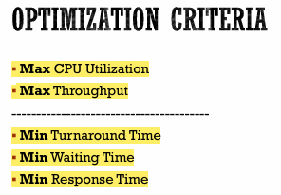
Throughput: No. of processes done / unit time.
Arrival time (AT): Time when process is arrives at the ready queue.
Burst time (BT): The time required by the process for its execution.
Completion Time (CT): Time taken till process gets terminated.
Turnaround time (TAT): Time taken from first time process enters ready state till it terminates (CT - AT)
Waiting time (WT): Time process spends waiting for CPU. (WT = TAT - BT)
Response time: Time duration between process getting into ready queue and process getting CPU for the first time.
Methods of Scheduling-
- FCFS (First Come First Serve)
  - First process to arrive gets the CPU first (non-preemptive).
  - Suffers from Convoy Effect: long BT process delays short ones → high WT, poor resource utilization.

- SJF (Non-Preemptive)
- Process with the smallest Burst Time (BT) executes first.
- Minimum average WT, but needs BT estimation and can cause starvation.
- SJF (Preemptive / SRTF)
- CPU always runs the process with the shortest remaining time.
- Less starvation, no convoy effect, and gives the minimum average WT.
- Priority Scheduling (Non-Preemptive)
- CPU is given to the process with the highest priority.
- Can cause starvation of low-priority processes.
- Priority Scheduling (Preemptive)
- A higher-priority arriving process preempts the current process.
- Starvation possible; Ageing (gradually increasing priority) is the solution.
- Round Robin (RR)
- Preemptive FCFS using a fixed Time Quantum (TQ); best for time-sharing systems.
- Fair scheduling with very low starvation and no convoy effect, but small TQ increases context-switch overhead.

Multi-Queueing
1. Multi-Level Queue (MLQ)
- Ready queue is split into multiple priority queues and a process is permanently assigned to one queue.
- Each queue has its own scheduling (RR/FCFS, etc.).
- Fixed-priority preemptive scheduling. Process in a higher queue preempts that in a lower queue.
- Problems: Starvation, Convoy effect.
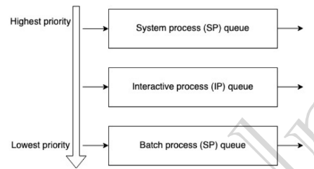
Created by OS (Highest priority)

(Foreground process): Needs user input.

(Background process): Runs silently, no user input required.

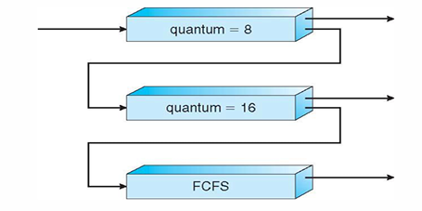
2. Multi-Level Feedback Queue (MLFQ)
- Multiple priority queues with different scheduling policies.
- Processes can move between queues based on CPU usage.
- CPU-bound processes are demoted; I/O bound/interactive processes stay in higher-priority queues.
- Ageing promotes long-waiting processes to high priority to prevent starvation.
- Flexible and dynamically adjusts priorities.
- Provides better response time, fairness, and CPU utilization than MLQ.
Concurrency
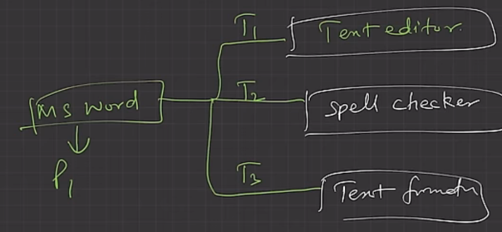
Concurrency is the execution of the multiple instruction sequences at the same time when there are several process threads running in parallel.
Thread is a subpart of a process which helps parts of process run asynchronously and parallelly to save time. Has independent path of execution. Light-weight process. All threads share the memory and address space.
Multi-threading does not have isolation and memory protection.
Thread Scheduling: OS schedules threads based on priority. Each thread gets a CPU time slice.
Thread Context Switching: Switches between threads of the same process. Saves PC, registers, and stack. No address space switch -> Faster than process switching. CPU cache mostly preserved. I/O or TQ based switching done using TCB.
CPU Access: Each thread has its own Program Counter (PC). OS scheduler selects the thread to execute using thread scheduling algorithms and fetch the instructions corresponding to the PC of that thread.
Benefits of multi-threading-
- Responsiveness
- Efficient resource sharing
- Economy: It is more economical to create and context switch threads. Also, allocating memory and resources for process creation is costly, so better to divide tasks into threads of same process.
- Better utilization of multiprocessors in terms of scale and efficiency.
Critical Section Problem
Process Synchronization- Ensures consistency of shared data and prevents incorrect results when multiple processes/threads execute concurrently by simultaneous access to shared resources.
Critical Section (CS)
Part of a program where shared resources (variables, files, etc.) are accessed or modified. Since processes/threads can be interrupted at any time, only one process/thread should execute the CS at a time.
Solution of CS should have 3 conditions->
- Mutual Exclusion-> One at a time.
- Progression-> No particular order of entering.
- Bonded Wait-> No indefinite Waiting to enter.
Race Condition
- Occurs when multiple threads/processes access and modify shared data simultaneously.
- Final result depends on the order in which threads are scheduled. Leads to unpredictable or incorrect outputs.
- Methods to Prevent Race Condition
- Atomic Operations: Execute critical code as one indivisible operation.
- Mutex/Locks: Provides mutual exclusion by allowing only one thread/process into the critical section.
  - Disadvantages-> Other threads busy-wait while lock is held (may wait indefinitely). Possibility of Deadlock. Difficult to debug. Can cause starvation for low priority threads.
- Semaphores: Synchronization mechanism to coordinate access to shared resources.
- Peterson’s Solution-> uses flag [2] and turn. Only for 2 threads.

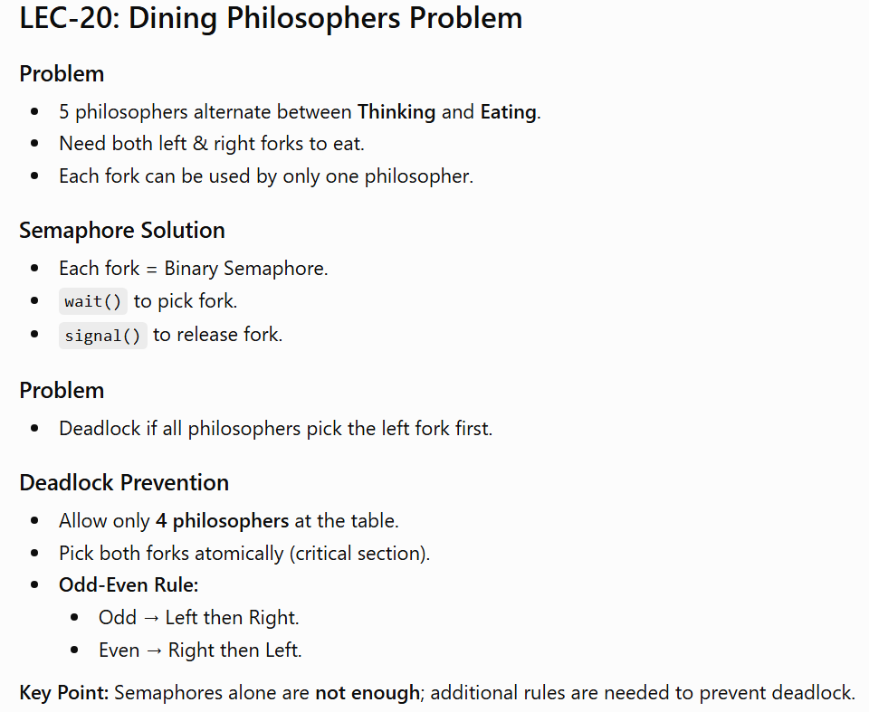
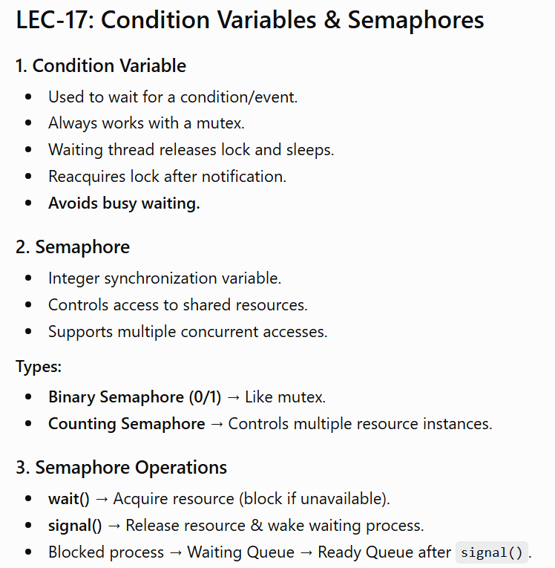

Deadlock
Deadlock- Occurs when multiple processes compete for limited resources.
- A process requests a resource; if unavailable, it enters the waiting state. If the required resource is never released, the process waits forever → Deadlock.
- In deadlock, two or more processes wait indefinitely for resources held by each other.
Effects of Deadlock
- Processes never complete execution.
- System resources remain occupied.
- Prevents other processes from executing.
- Considered a synchronization bug.
Examples of Resources- CPU, Memory, Files, Locks, Sockets, I/O devices.
A resource may have multiple instances (e.g., multicore CPUs).
Resource Usage Cycle
- Request resource.
- Use resource.
- Release resource after completion.
-> Necessary Conditions for Deadlock (Coffman Conditions)
All four conditions must occur simultaneously for deadlock to happen:
1. Mutual Exclusion
- A resource can be used by only one process at a time. Other processes must wait.
2. Hold and Wait
- A process holds one or more resources while waiting for additional resources held by others.
3. No pre-emption
- Resources cannot be forcibly taken back. They are released only voluntarily by the holding process.
4. Circular Wait
- A circular chain exists where: P₁ waits for P₂, P₂ waits for P₃, ..., Pₙ waits for P₁.

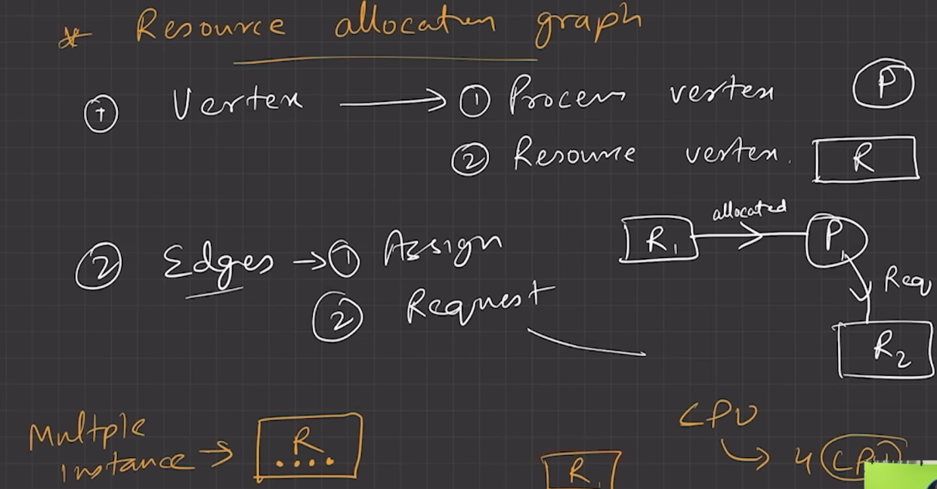
-> Methods for handling Deadlocks:
- Use a protocol to prevent or avoid deadlocks, ensuring that the system will never enter a deadlocked state.
- Allow the system to enter a deadlocked state, detect it, and recover.
- Ignore the problem altogether and pretend that deadlocks never occur in system. (Ostrich algorithm) aka, Deadlock ignorance.
No cycle in RAG- No Deadlock. If cycle in RAG- Maybe Deadlock.
To ensure that deadlocks never occur, the system can use either a deadlock prevention or deadlock avoidance scheme.

Deadlock prevention works by breaking any one of the four Coffman conditions (Mutual Exclusion, Hold & Wait, No pre-emption, or Circular Wait).
1. Mutual Exclusion
- Share resources whenever possible.
- Use locks only for non-shareable resources.
- Not always possible.
2. Hold & Wait
- Request all resources before execution, or
- Request new resources only after releasing current ones.
3. No Preemption
- If a requested resource is unavailable, pre-empt (take back) the resources currently held by the requesting process. Restart the process only after all required resources become available.
- Alternatively, pre-empt resources from a waiting process if possible.
4. Circular Wait
- Impose a fixed ordering on resource allocation. All processes must request resources in the same order (e.g., always lock R1 → R2).
Deadlock Avoidance Kernel knows maximum resource needs of each process in advance. Before granting a request, it checks if the system remains safe.
Considers:
  - Available resources
  - Allocated resources
  - Maximum future needs
Allocate resources so deadlock never occurs.
Safe State- A state where all processes can finish in some safe sequence.
Unsafe State- No guaranteed safe sequence. May lead to deadlock, but is not necessarily a deadlock.
Rule
- Grant a resource request only if the resulting state is safe.
Algorithm: Banker's Algorithm

-> Banker's Algorithm
This is the primary scheduling algorithm used to find safe states and avoid deadlocks.
- When a process requests resources, the Banker’s Algorithm simulates the allocation. If the simulation shows the system stays in a safe state, the resources are granted. If the result is an unsafe state, the requesting process is forced to wait until other processes release enough resources.
-> Deadlock Detection
If a system does not use prevention or avoidance techniques, it must periodically check if a deadlock has already occurred.
- Single Resource Instances: The system maintains a wait-for graph. If the algorithm detects a cycle, a deadlock exists.
- Multiple Resource Instances: The system uses a variation of the Banker's Algorithm to detect deadlocks.
-> Recovery from Deadlock
Once a deadlock is detected, the system must break it using one of two main methods:
- Process Termination: Abort all DL processes or Abort one process at a time until DL cycle is eliminated.
- Resource Preemption: Forcefully take resources from processes. Reallocate them until the deadlock is removed.

Memory Management Techniques
1. Need for Memory Management
- In multiprogramming, multiple processes reside in main memory simultaneously.
- Memory must be managed efficiently to:
  - Keep CPU utilization high.
  - Improve system responsiveness.
  - Allow multiple processes to share main memory safely.
2. Logical vs Physical Address Space
Logical Address (Virtual Address)
- Address generated by the CPU.
- Used by the program during execution. User can access only logical addresses.
- Does not physically exist in memory.
- Collection of all logical addresses = Logical Address Space (LAS).
- Range: 0 → max
Physical Address
- Actual address in main memory (RAM).
- User cannot access it directly. Program is actually stored here.
- Collection of all physical addresses = Physical Address Space (PAS).
- Range: R → (R + max) where R = Base Address.
3. Address Mapping (MMU)
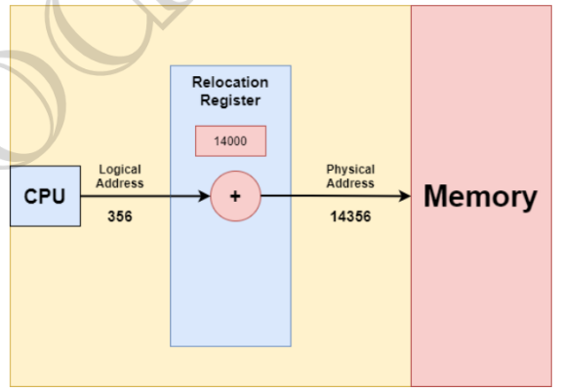
- MMU (Memory Management Unit) translates logical addresses → physical addresses.
- User/program works with logical addresses, while execution occurs using physical addresses.
Formula:
Physical Address = Base Register + Logical Address
4. Memory Mapping & Protection (OS Isolation)
- Virtual Address Space (VAS): Each process gets its own logical (virtual) address space.
- Purpose: Ensures a process accesses only its own legal memory, preventing interference with OS or other processes.
- Relocation (Base) Register: Stores the starting physical address (R) of the process.
- Limit Register: Stores the maximum valid logical address (process size).
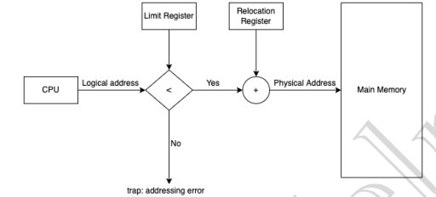
- Address Validation: Every logical address must satisfy Logical Address < Limit Register.
- MMU Translation: If valid, Physical Address = Base Register + Logical Address (dynamic address translation).
- Context Switch: During a context switch, the dispatcher loads the correct Base and Limit registers for the selected process.
- Protection: Every CPU-generated logical address is checked against these registers, protecting the OS and other processes.
- Illegal Access: Accessing OS memory or another process's memory causes a trap (fatal error).
- Address Translation Formula:
Physical Address = Base Register + Logical Address (only if Logical Address < Limit).
Allocation Methods on Physical Memory
- Contiguous Allocation – Process occupies one continuous block of memory.
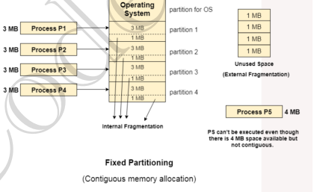
- Non-Contiguous Allocation – Process is divided and stored at different memory locations.
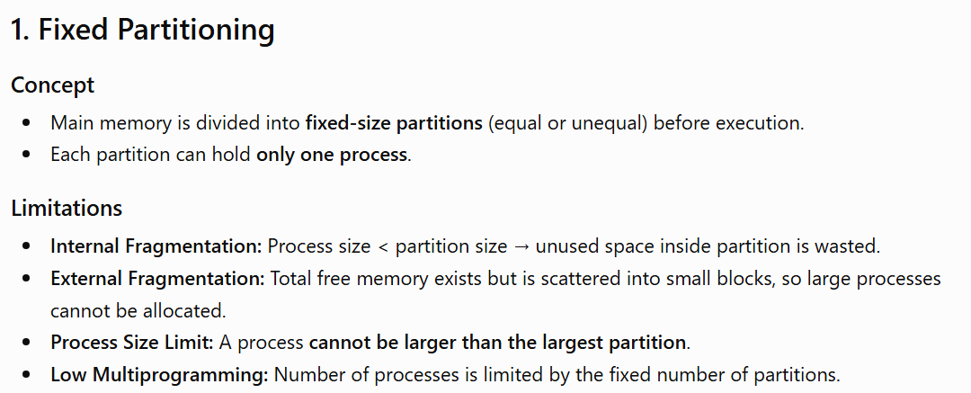
Contiguous Memory Allocation

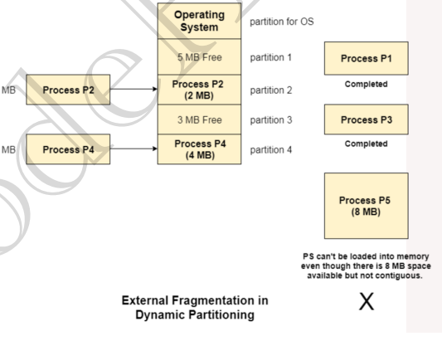
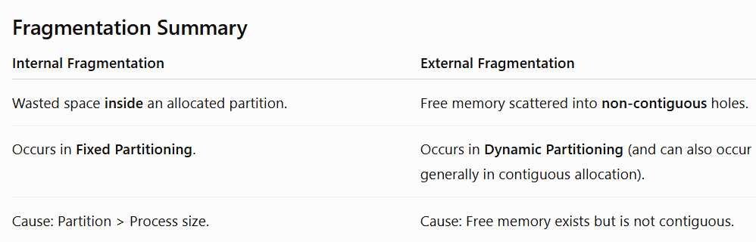
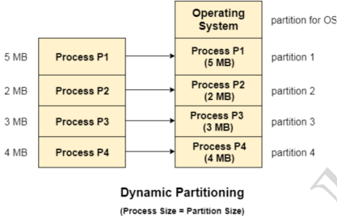
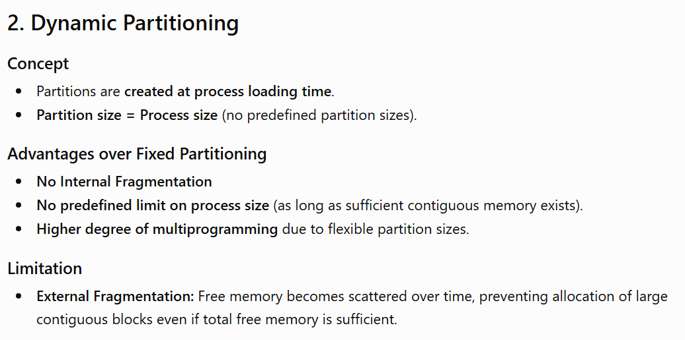

Free Space Management
1. Defragmentation (Compaction)
- Used to reduce external fragmentation in dynamic partitioning. All free memory blocks are merged into one contiguous block by moving allocated partitions together. Allows allocation of larger processes that previously couldn't fit.
- Drawback: Time-consuming and reduces system efficiency while memory is being reorganized.
2. Free memory holes are maintained using a Free List (Linked List).
3. Free Space Allocation Algorithms
First Fit- Allocates the first hole large enough for the process. Pros: Simple, fast, low search time.
Next Fit- Similar to First Fit, but starts searching from the last allocated position instead of the beginning.
Best Fit- Allocates the smallest hole that can accommodate the process.
Pros: Minimizes internal fragmentation. Cons: Slow (searches entire list); may create many small holes → high external fragmentation.
Worst Fit- Allocates the largest available hole.
Pros: Leaves larger free blocks for future allocations. Cons: Slow (searches entire list).
Non-Contiguous Memory Allocation
Paging
1. Why Paging?
- Dynamic Partitioning suffers from External Fragmentation. Compaction can remove it but has high overhead.
- Paging provides a more flexible and efficient solution. Memory management scheme that allows a process to occupy non-contiguous physical memory.
2. Idea Behind Paging
- Divide:
  - Physical Memory → Frames
  - Logical Memory → Pages
- Page Size = Frame Size
- Page size is decided by the processor architecture (commonly 4 KB).
- Pages of a process can be stored in any free frame (non-contiguously).
- Eliminates the need for contiguous memory allocation.
3. Page Table
- Stores the mapping of Page Number → Frame Number.
- Each entry contains the base address/frame number of a page in physical memory. Created when the process is loaded into memory.
- Base address of the page table is stored in the PCB.
- PTBR (Page Table Base Register) points to the current process's page table.
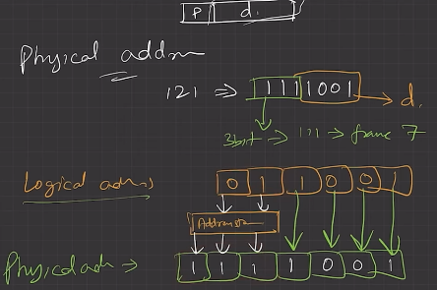
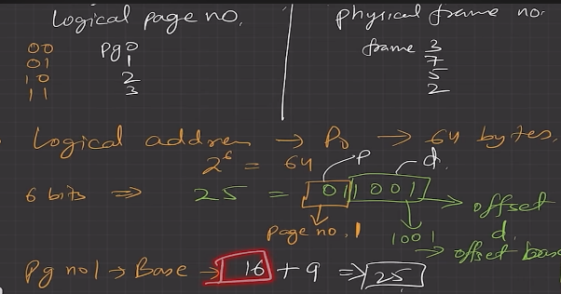
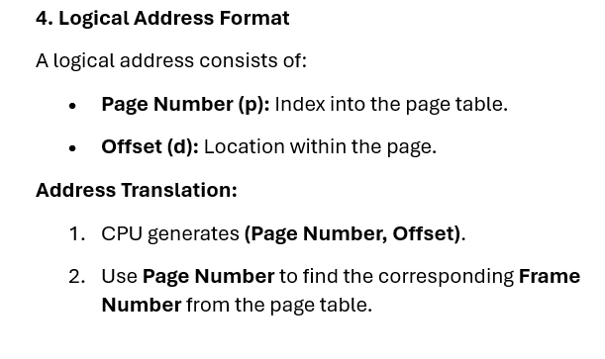
- During a context switch, only the PTBR needs to be updated.
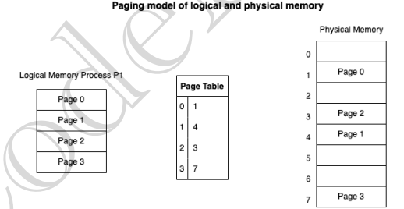
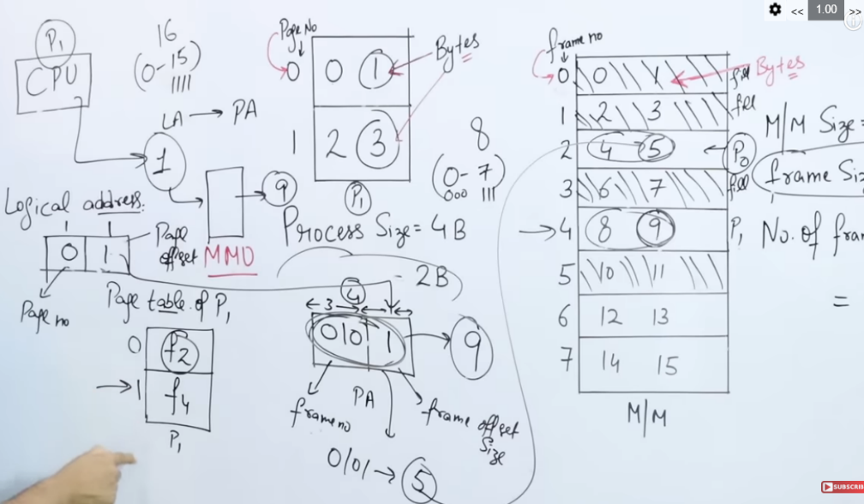
3. Physical Address = Frame Number + Offset.

6. How Paging Avoids External Fragmentation
- Pages can be placed in any available free frames.
- No requirement for one large contiguous memory block.

7. Translation Lookaside Buffer (TLB)
- TLB is a high-speed hardware cache that stores recent Page Number → Frame Number mappings.
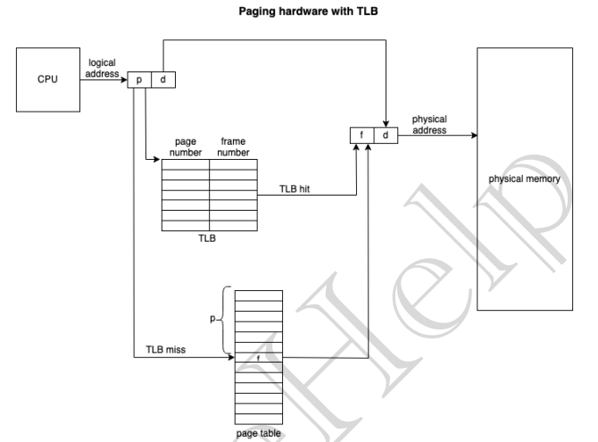
- Used to speed up address translation since the page table resides in main memory.
Working
- TLB Hit: Mapping found in TLB → Physical address obtained directly (fast).
- TLB Miss: Search the page table in memory, then update the TLB.
ASID (Address Space Identifier)
Stored in each TLB entry. Uniquely identifies a process. Prevents incorrect translations when multiple processes share the TLB.
If ASID doesn't match the current process → treated as a TLB Miss.
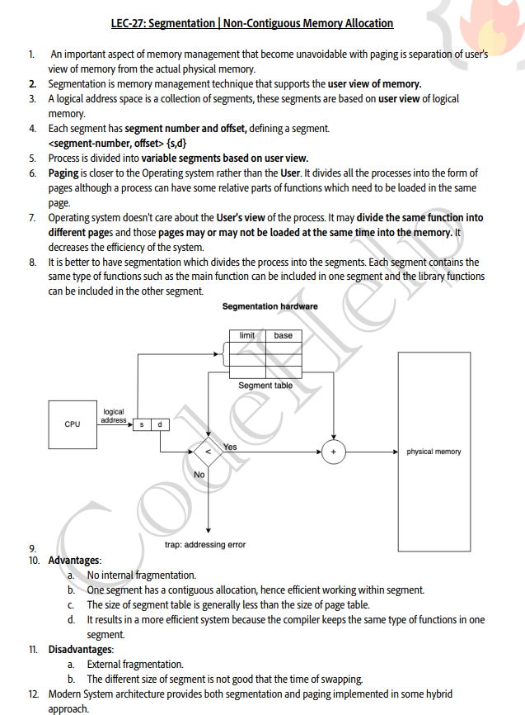
Virtual Memory || Demand Paging || Page Faults
1. What is Virtual Memory?
- Technique that allows execution of processes not completely loaded in main memory.
- Gives the illusion of a large main memory by using secondary storage (swap space).
- Allows programs to be larger than physical memory.
2. Advantages
- Programs are not limited by physical memory size.
- More processes can reside in memory simultaneously.
- Higher CPU utilization and better throughput.
- Efficient memory usage since only required pages are loaded.

Demand Paging
- Most common virtual memory technique.
- Only required pages are loaded into main memory.
- Less frequently used pages remain on secondary storage (swap space).
- A page is loaded only when it is referenced (Lazy Loading).
Pager vs Swapper
- Swapper: Moves entire processes.
- Pager: Moves individual pages (used in demand paging).
Working of Demand Paging
- Process starts execution with only required pages in memory. Remaining pages stay on disk.
- Valid-Invalid Bit in the page table indicates page status:
  - Valid (1): Page is legal and present in memory.
  - Invalid (0): Page is either outside the process address space or currently stored on disk.
- If an invalid page is accessed → Page Fault occurs.
- OS loads the required page into memory and resumes execution.
Page Fault
Definition
- Occurs when a process tries to access a valid page that is not currently in main memory.
Page Fault Handling Steps
- Hardware detects the invalid bit and traps to the OS.
- OS checks whether the memory reference is valid.
  - If invalid → terminate/raise exception.
  - If valid → continue page fault handling.
- Find a free frame in physical memory. Page replacement algorithms are used when no free frame is available.
- Read the required page from disk (swap space) into the free frame.
- Update the page table (frame number + valid bit = 1).
- Restart the interrupted instruction; execution continues normally.
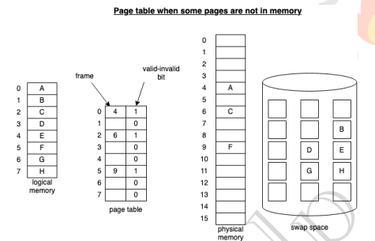
- If a page is never accessed, it never needs to be loaded into memory.

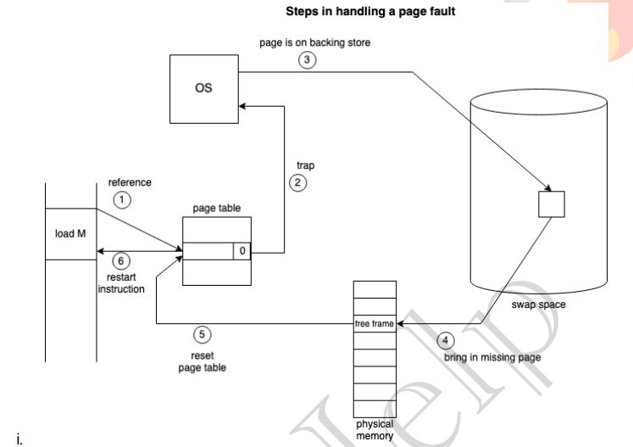

Pure Demand Paging
- Process starts with no pages in main memory.
- First instruction causes a page fault, and the required page is loaded.
- Pages are loaded only when actually needed.
- Relies on the principle of locality of reference for good performance.

Advantages of Virtual Memory
- Higher degree of multiprogramming.
- Can execute programs larger than physical memory.
- Better memory utilization (only required pages are loaded).
- Increased CPU utilization and system throughput.
Disadvantages of Virtual Memory
- Slower execution due to page swapping between disk and memory.
- Thrashing may occur if excessive page faults happen.

Page Replacement Algorithms
When a page fault occurs and no free frame is available, the OS must replace an existing page with the required page. Goal is to Minimize the number of page faults.

1. FIFO (First-In First-Out)- Replaces the oldest page (first page loaded into memory).
Advantages- Simple and easy to implement.
Disadvantages
- May remove frequently used pages.
- Suffers from Belady's Anomaly.
Belady's Anomaly- Increasing the number of frames may increase page faults (only in some algorithms like FIFO).

2. Optimal Page Replacement (OPT)- Replace the page that will not be used for the longest time in the future (or never used again).
Advantages- Minimum possible page faults (optimal).
Disadvantages- Requires future knowledge of page references. Not practical.
3. LRU (Least Recently Used)- Replace the page not used for the longest time in the past. Assumes recent past predicts near future (Locality of Reference).
Implementation
- Counter/Timestamp: Replace page with the oldest timestamp.
- Stack: Keep recently used pages at the top; replace the bottom (least recently used) page.
Advantages
- Better performance than FIFO.
- Does not suffer from Belady's Anomaly.

4. Counting-Based Algorithms
LFU (Least Frequently Used)
- Replace the page with the smallest reference count.
- Frequently used pages remain in memory.
MFU (Most Frequently Used)
- Replace the page with the highest reference count.
- Assumes pages with low counts were recently loaded and will be needed again.
Note: LFU and MFU are rarely used in practice.
Thrashing
Thrashing occurs when the system spends more time handling page faults than executing processes.
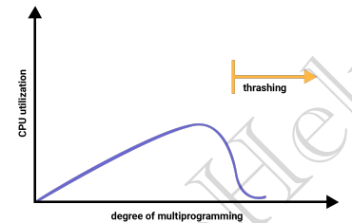
Cause
- A process has too few frames to hold its active pages.
- Frequent page faults lead to continuous page replacement.
Effect
- High page-fault rate.
- Excessive disk I/O.
- CPU utilization drops sharply.

Techniques to Prevent Thrashing
1. Working Set Model
- Based on the Locality of Reference principle.
- Allocate enough frames to hold the process's current working set (active pages).
- If frames are insufficient, thrashing occurs.
2. Page Fault Frequency (PFF)
- Monitor the page fault rate.
- Set upper and lower thresholds:
  - Page fault rate > Upper limit → Allocate more frames.
  - Page fault rate < Lower limit → Remove extra frames.
- Maintains an optimal page-fault rate and prevents thrashing.

